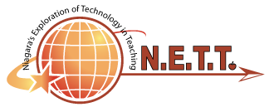
SAVE THE DATE

2019 N.E.T.T. CONFERENCE!
FULL STEAM AHEAD…
August 20, 2019, 8:30am-3pm
At Niagara University

In collaboration with Niagara University College of Education and Orleans/Niagara BOCES, the Orleans-Niagara Teacher Center would like to invite you to a fun-filled, interactive day all about educational technology. The event will include a keynote, 75 minute hands-on breakout sessions, a flash share out, and prize giveaways.
Cost is only $30. Participants are eligible for 6 hours of CTLE credit. Food trucks will be available on site at your own expense.
Discover engaging ways to incorporate technology into your classroom to enrich your students’ learning and increase motivation. Breakout sessions will be available for all levels of learners from all grade levels and content areas.
Registration is OPEN!

For more information and to register, please contact Cheryl Herman, cherman@onboces.org. Session descriptions available here.

